Balancing Redox Reactions: Half-Reaction Method
Another method for balancing redox reactions (besides using oxidation states) uses half-reactions. Recall that a half reaction is either the oxidation or reduction that occurs, treated separately. The half reaction method works better than the oxidation-number method when the substances in the reaction are in aqueous solution. The aqueous solution is typically either acidic or basic, so hydrogen ions or hydroxide ions are present.
In general, the half-reactions are first balanced by atoms separately. Electrons are included in the half-reactions. These are then balanced so that the number of electrons lost is equal to the number of electrons gained. Finally, the two half-reactions are added back together. The example is the oxidation of Fe²⁺ ions to Fe³⁺ ions by dichromate (Cr2O₇²⁻) in acidic solution. The dichromate ions are reduced to Cr³⁺ ions.
Step 1: Write the unbalanced ionic equation.

Notice that the equation is far from balanced, as there are no oxygen atoms on the right side. This will be resolved by the balancing method.
Step 2: Write separate half-reactions for the oxidation and the reduction processes. Determine the oxidation numbers first, if necessary.
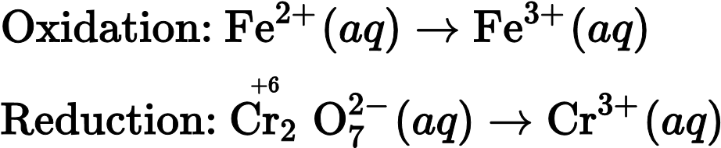
Step 3: Balance the atoms in the half-reactions other than the hydrogen and oxygen. In the oxidation half-reaction above, the iron atoms are already balanced. The reduction half-reaction needs to be balanced with the chromium atoms.

Step 4: Balance oxygen atoms by adding water molecules to the appropriate side of the equation. For the reduction half-reaction above, seven H2O molecules will be added to the product side.

Now the hydrogen atoms need to be balanced. In an acidic medium, add hydrogen ions to balance. In this example, fourteen H⁺ ions will be added to the reactant side.

Step 5: Balance the charges by adding electrons to each half-reaction. For the oxidation half-reaction, the electrons will need to be added to the product side. For the reduction half-reaction, the electrons will be added to the reactant side. By adding one electron to the product side of the oxidation half-reaction, there is a 2+ total charge on both sides.

There is a total charge of 12+ on the reactant side of the reduction half-reaction (14 – 2). The product side has a total charge of 6+ due to the two chromium ions (2 × 3). To balance the charge, six electrons need to be added to the reactant side.

Now equalize the electrons by multiplying everything in one or both equations by a coefficient. In this example, the oxidation half-reaction will be multiplied by six.

Step 6: Add the two half-reactions together. The electrons must cancel. Balance any remaining substances by inspection. If necessary, cancel out H2O or H⁺ that appear on both sides.
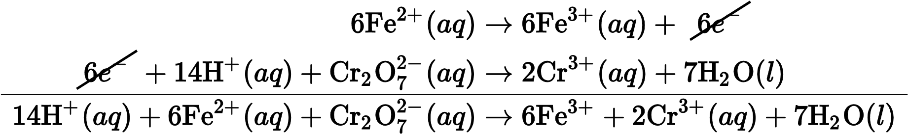
Step 7: Check the balancing. In the above equation, there are 14 H, 6 Fe, 2 Cr, and 7 O on both sides. The net charge is 24+ on both sides. The equation is balanced.

Review
- Why do you need the unbalanced ionic equation?
- What does balancing each half-reaction separately tell you?
- How do you balance hydrogens in an acidic medium?

